Q1. PYTHON3
You are given a string S representing an equation in the format: a + b = c + d. Each of the four operands (a, b, c, and d) may be
· A single-digit integer (1-9), or
. An unknown, represented by the operand's name ("a", "b", "c", or "d").
At least one operand on the left side (a or b) and one operand on the right side (c or d) is known. Your task is to find and return a string representing the values of all four operands, sorted in ascending order as four integers.
Note: The equation is always valid and has a unique solution.
Input Specification:
input1 : A string S
Output Specification:
Return a string representing the values of all four operands,
sorted in ascending order as four integers
Example 1:
input1: 2+4=c+5
Output : 1 2 4 5
Explanation:
Here the string S is "2+4=c+5". We can see that:
· a = 2 (known)
· b = 4 (known)
· c =? (unknown)
· d = 5 (known)
So, the equation becomes:
2 + 4 = c + 5
6= c + 5
c=1
After sorting the value in ascending order, we get 1, 2, 4 and 5.
Hence, 1 2 4 5 is returned as the output.
Example 2:
input1: a+3=5+6
Output : 3 5 6 8
Explanation:
Here the string is S "a+3=5+6". We can see that:
a =?
b= 3
c= 5
d = 6
So, the equation becomes:
·a+3 = 5 + 6
. a + 3 = 11
· a = 8
After sorting the value in ascending order, we get 3, 5, 6 and 8.
Hence, 3 5 6 8 is returned as the output.

Code Format should be like: (complier py 3.11) (give code completely i will fill accordingly)
# Read only region start
class UserMainCode(object):
@classmethod
def fourVariables(cls, input1):
...
input1 : string
Expected return type : string
# Read only region end
# Write code here
pass
answer
class UserMainCode(object):

@classmethod
def fourVariables(cls, input1):

left, right = input1.split("=")
x1, x2 = left.split("+")
x3, x4 = right.split("+")

for a in range(1, 10):
for b in range(1, 10):
for c in range(1, 10):
for d in range(1, 10):

# Check known values
if x1.isdigit() and a != int(x1):
continue
if x2.isdigit() and b != int(x2):
continue
if x3.isdigit() and c != int(x3):
continue
if x4.isdigit() and d != int(x4):
continue

# Check equation
if a + b == c + d:
arr = sorted([a, b, c, d])
return " ".join(map(str, arr))

Q2 How to Attempt?
Write an SQL query to display:
Staff name, position and total sales (sum of total amounts) for each staff member. Display the output in descending order of total sales.
Note:
· If first name is 'John' last name is 'Doe' then staff name will be displayed as 'John Doe'.
· Consider the amounts from the orders which are 'Completed'.
Your output should have 3 columns as given below:
STAFFNAME | POSITION | TOTALSALES
You can view the database schema by clicking the View Schema tab at the bottom of the query window on the right-hand side of the screen.
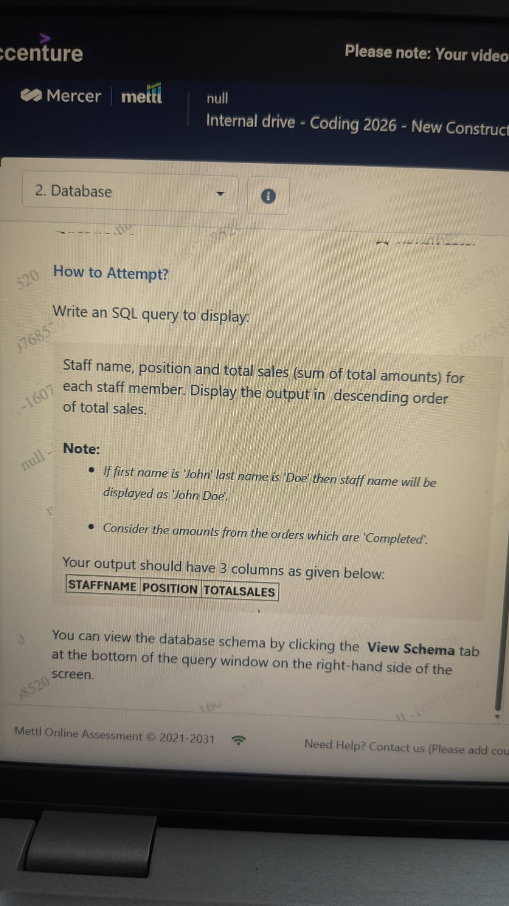

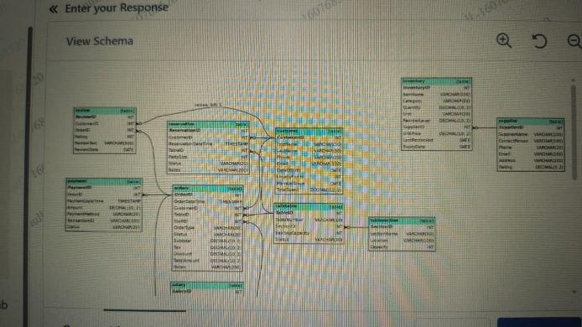
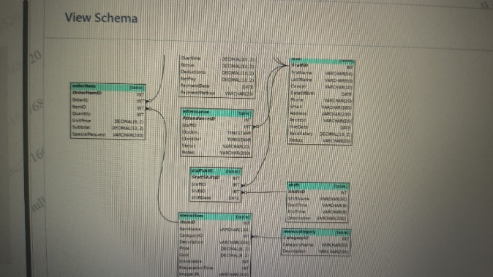

Answer
SELECT CONCAT(s.first_name, ' ', s.last_name) AS STAFFNAME,
s.position AS POSITION,
SUM(o.total_amount) AS TOTALSALES
FROM staff s
JOIN orders o
ON s.staff_id = o.staff_id
WHERE o.status = 'Completed'
GROUP BY s.staff_id, s.first_name, s.last_name, s.position
ORDER BY TOTALSALES DESC;

Q3. Front end Technology
Build a warm tea timer panel where users can pick minutes and instantly see how long to steep their cup.
Objectives:
. Add the min attribute with value "1" to the minutes input so shorter times cannot be chosen
. Give the. timer-card a linear-gradient (135deg, #ffaf40, #ff6b6b) background to brighten the panel
· Update updateSteepMessage so it shows the entered minutes and falls back to 3 minutes when the value is missing or below 1
Constraints:
. Do not modify any existing structure or element relationships
. Make sure your solution maintains the existing functionality
NOTE: CHECK SCREENSHOT PROPERLY FOR ALL THE CODES
HIGHTLIGHT AND GIVE WHERE ALL CHANGES IS NEEDED TO BE DONE IN EXISTING CODE, WHERE TO ADD NEW ONES ?

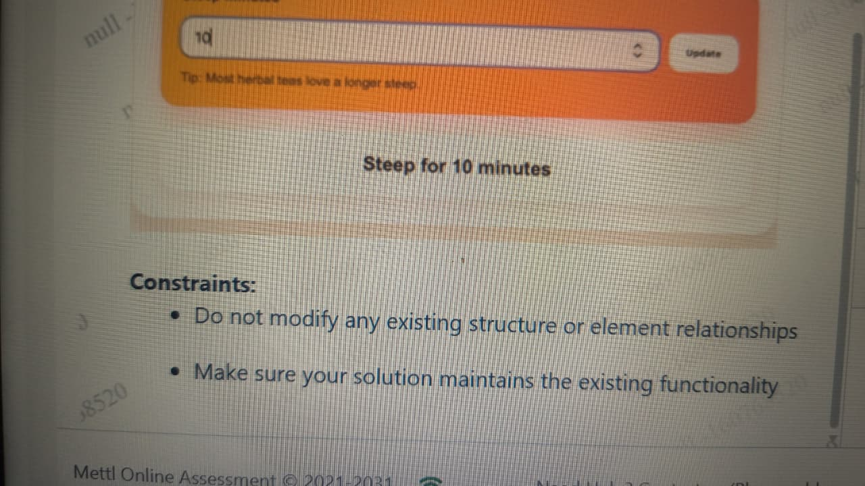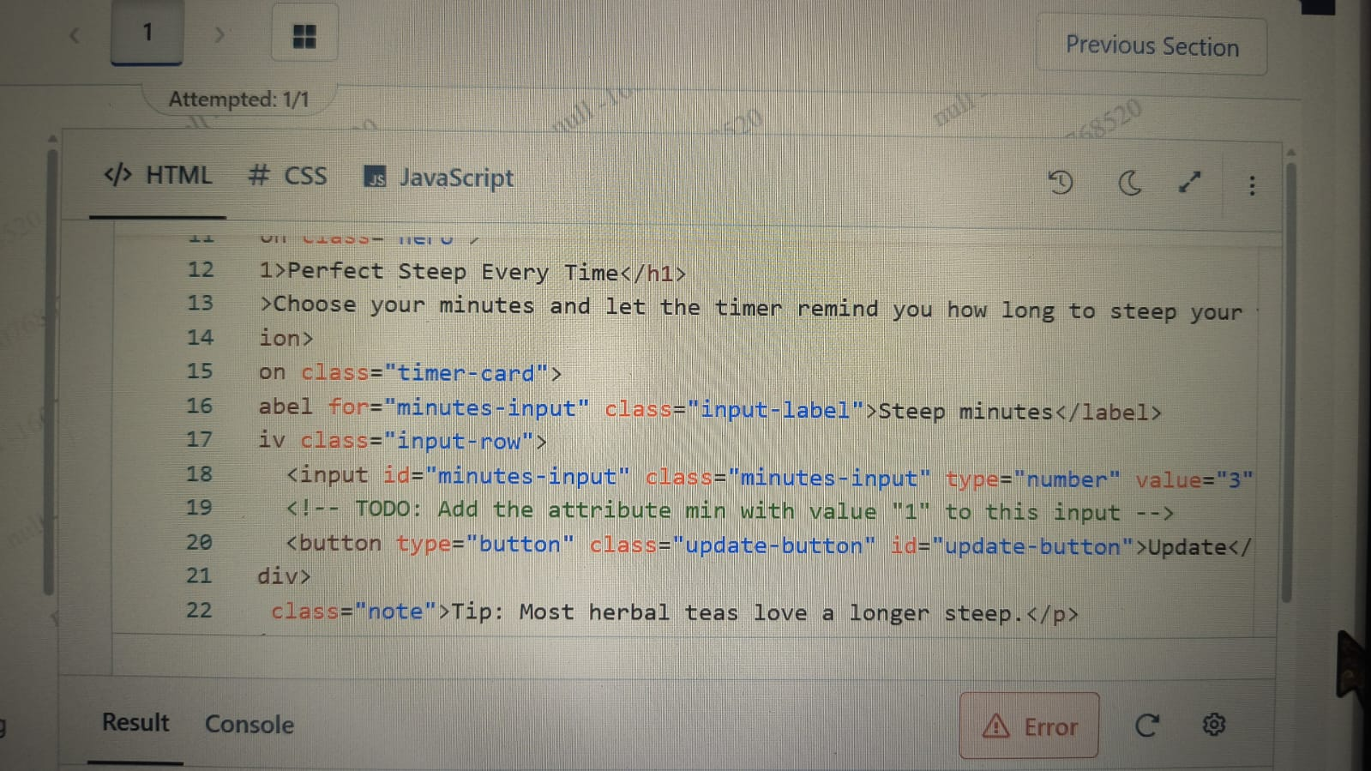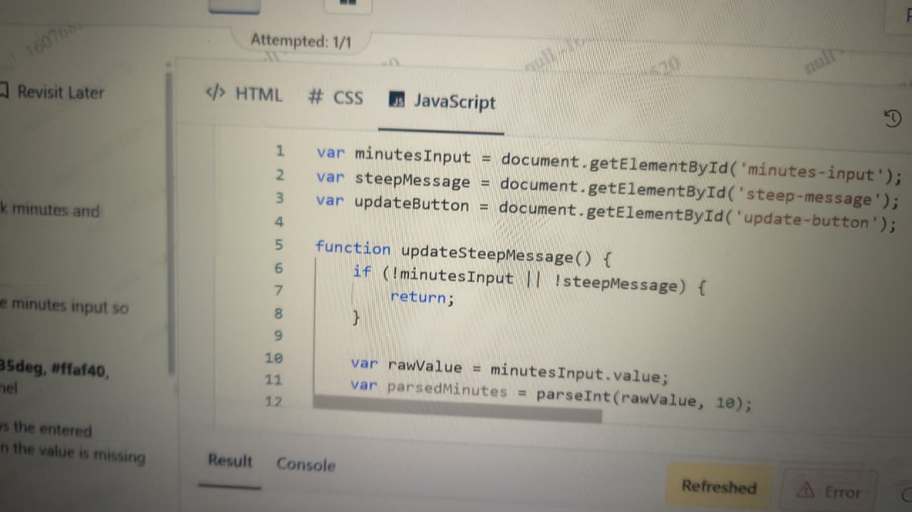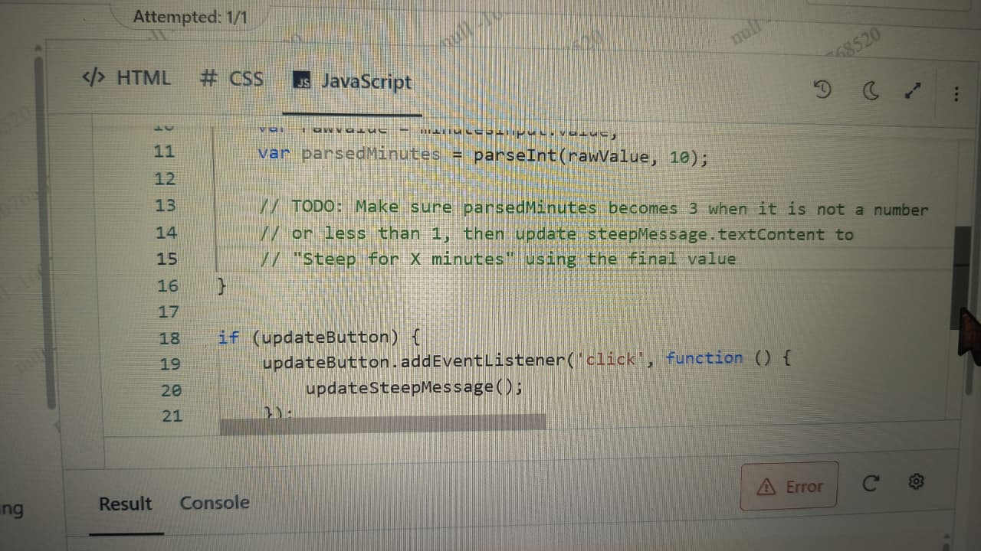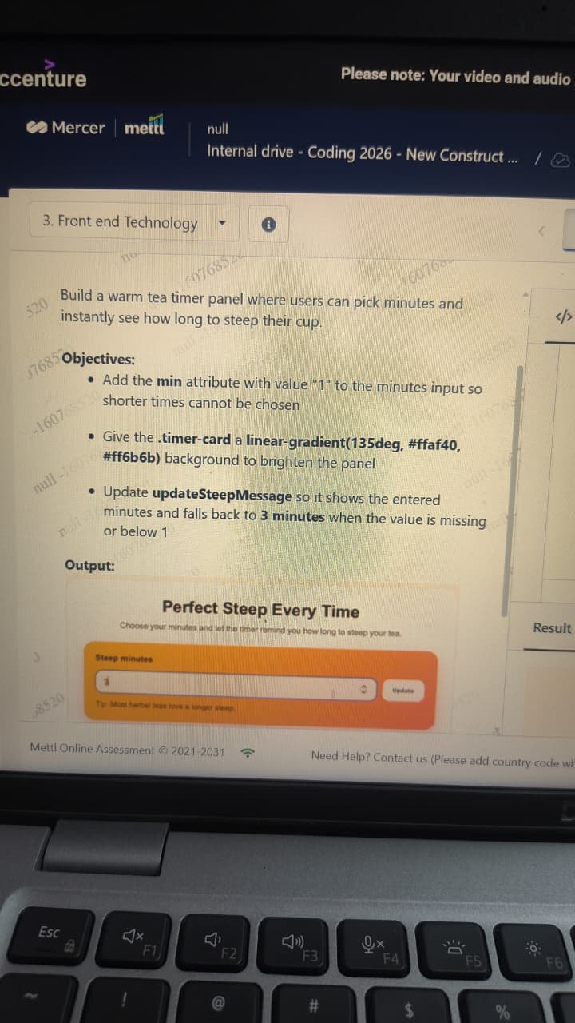

You only need to change 3 places.
1. HTML
Find:
<input id="minutes-input" class="minutes-input" type="number" value="3">
Replace with:
<input id="minutes-input" class="minutes-input" type="number" value="3" min="1">

2. CSS
Find:
.timer-card {
Add:
background: linear-gradient(135deg, #ffaf40, #ff6b6b);
Example:
.timer-card {
background: linear-gradient(135deg, #ffaf40, #ff6b6b);
}

3. JavaScript
Replace the TODO section with:
if (isNaN(parsedMinutes) || parsedMinutes < 1) {
parsedMinutes = 3;
}

steepMessage.textContent = "Steep for " + parsedMinutes + " minutes";
So the function becomes:
function updateSteepMessage() {
if (!minutesInput || !steepMessage) {
return;
}

var rawValue = minutesInput.value;
var parsedMinutes = parseInt(rawValue, 10);

if (isNaN(parsedMinutes) || parsedMinutes < 1) {
parsedMinutes = 3;
}

steepMessage.textContent =
"Steep for " + parsedMinutes + " minutes";
}
These changes satisfy all three requirements:
- min="1"
- Gradient background
- Default to 3 minutes when input is empty or less than 1.

